CLINICAL AND BEHAVIORAL DETERMINANTS OF DENTIN SENSITIVITY AMONG DENTAL STUDENTS: AN INSTITUTIONAL CROSS-SECTIONAL STUDY

Giuseppe Eliseo ALLOCCA ¹, Alexandrina MUNTEAN ^{2,*}, Cristian Doru OLTEANU ^{3,*}, Sorana Maria BUCUR ⁴

¹ Oral Surgery and Implantology IRCSS – School of Dentistry, University of Milan, Dental Clinic, Via Commenda 10, 20122 Milano, Italy
² Department of Pedodontics, Faculty of Dental Medicine, University of Medicine and Pharmacy “Iuliu Hațieganu”, Str. Avram Iancu 31, 400083 Cluj-Napoca
³ Department of Orthodontics, School of Dental Medicine, University of Medicine and Pharmacy Iuliu Hațieganu, Str. Avram Iancu 31, 400083 Cluj-Napoca
⁴ Department of Dental Medicine, Faculty of Medicine, University of Târgu Mureș, 540545 Târgu Mureș

Abstract

Dentin hypersensitivity (DH) is a frequent condition associated with exposed dentinal tubules, typically triggered by thermal, tactile, or osmotic stimuli. While its general prevalence is well established, limited data exist on the DH risk in dental students, a population uniquely exposed to behavioral and occupational risk factors. Methods: A cross-sectional observational study was conducted among 227 undergraduate dental students at a Romanian university. Clinical DH diagnosis was made using standardized tactile and thermal stimuli. Behavioral data, including dietary and oral hygiene habits, were collected via a structured questionnaire. Risk factors were analyzed using multivariate regression. Results: The prevalence of DH was 21.6% (n=49), with increased prevalence in advanced academic years (35.1% in Year VI vs. 9.5% in Year I). Females had a higher relative prevalence (25.6%) than males (20.7%). The most common associated factors included frequent acidic foods or drinks (67.3%), aggressive brushing (55.1%), whitening (42.9%), and prior bleaching treatments (36.7%). Maxillary premolars (73.5%), mandibular premolars (59.2%), and maxillary canines (53.1%) were the most affected teeth. Conclusions: DH is a common pathology among dental students, with prevalence depending on clinical exposure and study year. Behavioral habits play a significant role in DH onset. Preventive strategies targeting modifiable behaviors should be incorporated early in dental training.

Keywords: Dentin hypersensitivity; dental students; prevalence; acid erosion; brushing habits; tooth whitening; dental education

Introduction

Dentin hypersensitivity (DH) presents as short, sharp pain resulting from dentin exposure to external stimuli—thermal, chemical, tactile, or osmotic—in the absence of overt dental pathology [1,2]. The hydrodynamic theory remains the most accepted explanation, attributing pain to fluid shifts within exposed dentinal tubules that stimulate mechanoreceptors in the pulp [3].
DH has a complex, multifactorial etiology requiring both dentin exposure and open tubules. Etiologic pathways include mechanical abrasion (e.g., aggressive toothbrushing), chemical erosion (dietary acids), attrition (disfunctional habits), and iatrogenic factors (e.g., bleaching, periodontal therapy) [4–7].
Reported prevalence ranges between 11% and 42%, depending on study design and population characteristics [8–10]. However, there is a paucity of studies focusing specifically on dental students, a group exposed to unique risk profiles due to professional training, increased awareness, and use of whitening agents. Furthermore, clinical stress and repeated exposure to prophylactic procedures may inadvertently promote gingival recession and cervical wear.
This study aims to assess the prevalence, anatomical distribution, and associated behavioral and clinical risk factors for DH among Romanian dental students from Years I to VI.

Materials and Methods

Study design and participants
A cross-sectional study was performed in March–April 2025 at the Faculty of Dental Medicine, Târgu Mureș, Romania. A convenience sample of 227 undergraduate students (aged 19–45 years) voluntarily participated. Ethics approval was granted by the university’s research ethics committee (16/CEU/2024), and informed consent was obtained from all participants.

Inclusion Criteria:
- Enrollment in Years I–VI of dental studies
- Signed informed consent

Exclusion Criteria:
- Active dental pain of other origin
- Neurological/systemic conditions affecting pain perception
- Use of analgesics or desensitizing agents within 48 hours

Questionnaire
Participants completed a structured, pre-validated questionnaire comprising:
- Demographics (age, gender, academic year)
- Self-reported DH symptoms (duration, triggers)
- Oral hygiene practices (brushing frequency, method, toothpaste type)
- Dietary habits (acidic food/drink consumption)
- Use of whitening products or prior bleaching
- History of bruxism or reflux

Clinical Assessment
- DH was confirmed via tactile and thermal tests performed by calibrated examiners.
- Tactile Test: Gentle probing of cervical regions using a blunt probe, scored 0–3
- Thermal Test: 1-second cold air blast from a dental syringe
- A response score ≥2 (pain/discomfort with withdrawal) confirmed DH, in the absence of other pathology.
- Teeth were charted using the FDI numbering system. The location and type of DH were recorded.

Statistical Analysis
Descriptive statistics were used to determine prevalence and distribution. Associations between risk factors and DH were analyzed using chi-square tests and logistic regression. A p-value < 0.05 was considered statistically significant.

Results

Sample characteristics
Of 227 students, 39 (17.2%) were female and 188 (82.8%) were male. Distribution by academic year is summarized in Table 1 & Figure 1.

Table 1. Participant distribution by academic year and gender

Year | Female | Male | Total | DH Prevalence
1 | 4 | 17 | 21 | 9.5%
2 | 6 | 23 | 29 | 10.3%
3 | 8 | 27 | 35 | 17.1%
4 | 8 | 45 | 53 | 17.0%
5 | 3 | 29 | 32 | 28.1%
6 | 10 | 47 | 57 | 35.1%

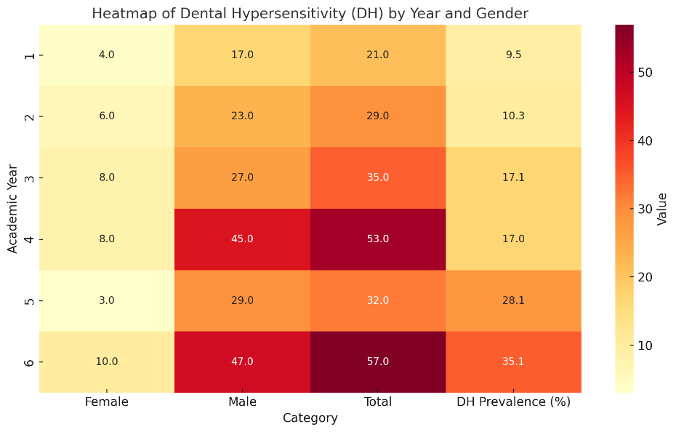
Figure 1. Heatmap on DH distribution

DH Prevalence and Gender Differences
- Overall DH prevalence: 21.6% (49/227)
- Females: 25.6%
- Males: 20.7%
DH prevalence increased with academic progression, peaking in Year VI (35.1%).

Risk Factor Distribution (n = 49 with DH)

Table 2. Frequency of associated risk factors in DH-positive participants

Risk Factor | Frequency | % (n=49)
Frequent acidic food/drink consumption | 32 | 65.3%
Aggressive or improper brushing technique | 26 | 54.1%
Whitening toothpaste usage | 23 | 44.9%
History of dental bleaching | 18 | 36.2%
Periodontal disease or gingival recession | 16 | 32.6%
Bruxism | 14 | 28.6%
Use of low-pH mouthwash | 10 | 20.3%
Gastric reflux | 7 | 14.0%

Tooth Distribution of DH

Table 3. Most commonly affected teeth by group

Tooth Group | Affected % (n=46)
Maxillary premolars | 63.5%
Mandibular premolars | 55.2%
Maxillary canines | 58.3%
Maxillary incisors | 32.6%
Mandibular incisors | 19.7%
Mandibular molars | 18.2%

Discussion

This cross-sectional study revealed a dental sensitivity (DS) prevalence of 21.6% among undergraduate dental students, a value comparable to previous university-based findings in Europe and Latin America, which report prevalence ranges between 20% and 35% [1–3]. The observed increase in DS prevalence across academic years—from 9.5% in Year I to over 35.1% in Year VI—suggests a strong cumulative exposure to behavioral and clinical risk factors.
A key observation was the correlation between DS and academic progression. This likely reflects greater clinical involvement, stress, and routine use of oral hygiene tools and products that may compromise tooth integrity. Similar trends have been reported by Mosquim et al. (2025) and Zeni et al. (2024), who emphasized increased gingival recession and enamel abrasion in advanced students due to repetitive clinical instrumentation and intensified self-care routines [2,4].
The higher relative prevalence among female students (25.6%) compared to males (20.7%) is consistent with previous research. Silva et al. (2019) and West et al. (2014) proposed that gender-based differences in pain perception thresholds, enamel thickness, and hygiene practices may account for this discrepancy [5,6]. Additionally, aesthetic motivations may prompt higher rates of cosmetic procedures, including bleaching, among female students. Dietary habits emerged as the most influential modifiable factor. Over two-thirds of DS-positive participants reported consuming acidic beverages (e.g., soda, citrus juices, energy drinks) at least three times per week. Acidic substances compromise enamel and cementum, increase dentinal tubule patency, and reduce surface microhardness, thereby promoting hypersensitivity [7–9]. This supports findings by Favaro Zeola et al. (2019), whose meta-analysis confirmed erosive dietary habits as a major global contributor to DH prevalence [3].
Improper brushing technique, particularly horizontal or "scrubbing" motion, was significantly associated with DS (OR 2.4). This pattern is well-documented in the literature as a cause of cervical abrasion and gingival recession, both of which facilitate dentin exposure [10,11]. Moreover, medium- or hard-bristle toothbrushes often used with excessive pressure amplify mechanical damage to enamel, especially in combination with acidic exposure.
A significant proportion (35.8%) of DS cases had undergone tooth bleaching within the past year. Hydrogen peroxide-based agents are known to diffuse through enamel and dentin, affecting the pulp-dentin complex and often triggering temporary or persistent hypersensitivity [12–14]. Liu et al. (2020) and Hassan et al. (2024) emphasized the importance of regulating bleaching frequency and concentration to minimize side effects, particularly among patients with predisposing enamel defects [12,13].
Our analysis also confirms that DS is most commonly localized to maxillary canines and premolars, regions with naturally thinner enamel at the cervical margin and higher exposure during routine brushing [10,15]. This finding is echoed by Ghimire et al. (2025), who described these teeth as anatomical "risk zones" for DH due to their positioning and morphology [15].
Psychological factors such as stress, though not directly measured in our study, are hypothesized to play a role in bruxism and parafunctional habits, which in turn contribute to DS. Academic pressure in dental education has been linked to behavioral changes such as jaw clenching or nighttime grinding, which cause enamel wear [16]. Future research should include psychometric assessments to quantify the role of stress and coping behaviors in DS development.
Importantly, our study reinforces the multifactorial nature of DS, where chemical, mechanical, and behavioral factors often interact synergistically. [16-20]. Most affected students reported at least two contributing factors, underscoring the synergistic effect of behavioral, chemical, and mechanical insults to tooth structures. This highlights the need for integrative educational strategies within dental curricula—ones that emphasize not only clinical knowledge but also personal preventive care. Curricula should address not only theoretical and clinical training but also the importance of personal oral health maintenance, safe self-care practices, and awareness of modifiable risk behaviors.
This study confirms that dentin sensitivity (DS) is a prevalent and progressively intensifying condition among undergraduate dental students, with a clear upward trend from the first to the final academic year.
Key contributing factors include the frequent intake of acidic beverages, improper brushing techniques, and a high incidence of tooth bleaching—all of which compromise enamel integrity and expose dentin. Notably, female students showed a higher prevalence, possibly due to gender-related biological and behavioral variables. The frequent involvement of maxillary canines and premolars further supports anatomical susceptibility patterns documented in prior literature.
Curricula should address not only theoretical and clinical training but also the importance of personal oral health maintenance, safe self-care practices, and awareness of modifiable risk behaviors.
Finally, the potential influence of psychological stress and parafunctional habits, such as bruxism [17,18,20], warrants further exploration. Integrating mental health awareness and stress management strategies into dental education could serve as a valuable adjunct in mitigating DS risk among students.

Conclusions

Dentin sensitivity (DS) affects over a quarter of dental students, with prevalence rising notably across academic years. This trend reflects cumulative exposure to clinical, behavioral, and lifestyle risk factors such as acidic diets, improper brushing, and bleaching. Female students showed higher DS rates, likely due to biological and behavioral differences. Maxillary canines and premolars were the most affected teeth. Results underscore the need for integrative prevention strategies in dental curricula, emphasizing not only clinical competency but also personal oral care and behavior modification.

References

- Colak H, Aylikci BU, Hamidi MM, Uzgur R. Prevalence of dentine hypersensitivity among university students in Turkey. Niger J Clin Pract. 2012;15(4):415–419. doi:10.4103/1119-3077.104514
- Mosquim V, Zabeu GS, Jacomine JC, Santin DC, Honório HM, Wang L. Brazilian undergraduates’ and dentists’ knowledge on preventing, diagnosing and managing dentin hypersensitivity: A cross-sectional questionnaire study. Int J Dent Hyg. 2025;23(1):3–13. doi:10.1111/idh.12833
- Favaro Zeola L, Soares PV, Cunha-Cruz J. Prevalence of dentin hypersensitivity: Systematic review and meta-analysis. J Dent. 2019;81:1–6. doi:10.1016/j.jdent.2018.12.015
- Zeni TC, Cardoso PMF, Vanolli RDS, et al. Single-session associative protocol for dentin hypersensitivity management: A 1-year randomized, blinded clinical study. Restor Dent Endod. 2024;49:e15. doi:10.5395/rde.2024.49.e15
- Silva MS, Lima ANAN, Pereira MMA, et al. Prevalence and predictive factors of dentin hypersensitivity in Brazilian adolescents. J Clin Periodontol. 2019;46(4):448–456. doi:10.1111/jcpe.13097
- West N, Seong J, Davies M. Dentine hypersensitivity. Monogr Oral Sci. 2014;25:108–122. doi:10.1159/000360749
- Dundar A, Sengun A. Dental approach to erosive tooth wear in gastroesophageal reflux disease. Afr Health Sci. 2014;14(2):481–486. doi:10.4314/ahs.v14i2.28
- Haneet RK, Vandana KL. Prevalence of dentinal hypersensitivity and study of associated factors. Int Dent J. 2016;66:49–57. doi:10.1111/idj.12206
- Dionysopoulos D, Gerasimidou O, Beltes C. Dentin hypersensitivity: Etiology, diagnosis and contemporary therapeutic approaches. Appl Sci. 2023;13(21):11632. doi:10.3390/app132111632
- Grover V, Kumar A, Jain A, et al. ISP good clinical practice recommendations for the management of dentin hypersensitivity. J Indian Soc Periodontol. 2022;26:307–333. doi:10.4103/jisp.jisp_233_22
- Clark D, Levin L. Non-surgical management of tooth hypersensitivity. Int Dent J. 2016;66:249–256. doi:10.1111/idj.12247
- Liu XX, Tenenbaum HC, Wilder RS, et al. Pathogenesis, diagnosis and management of dentin hypersensitivity. BMC Oral Health. 2020;20:220. doi:10.1186/s12903-020-01199-z
- Bin Hassan SA. Tooth sensitivity following hydrogen peroxide bleaching with and without ozone. Pain Res Manag. 2024;2024:2695533. doi:10.1155/2024/2695533
- Wright JT. Enamel phenotypes: Genetic and environmental determinants. Genes. 2023;14(3):545. doi:10.3390/genes14030545
- Ghimire S, Paudel N, Dahal S, et al. Prevalence of dentinal hypersensitivity among dental patients visiting tertiary care center. JNMA J Nepal Med Assoc. 2025;63:78–82. doi:10.31729/jnma.8881
- Agheli N, De Faria Neiva G, Maia RR, et al. Dentists’ education, knowledge, and behavior concerning DH diagnosis and treatment. J Dent Educ. 2023;87(12):1705–1717. doi:10.1002/jdd.13363
- Sutin AR, Terracciano A, Ferrucci L, Costa PT Jr. Teeth grinding: Is emotional stability related to bruxism? J Res Pers. 2010. 44, 3. 402–405. doi:10.1016/j.jrp.2010.03.006.
- Thayer LT, Ali R. The dental demolition derby: bruxism and its impact – Part 1: Background. Br Dent J. 2022. 232, 8. 515–521. doi:10.1038/s41415-022-4143-8.
- Nota A, Pittari L, Paggi M, Abati S, Tecco S. Correlation between bruxism and gastroesophageal reflux disorder and their effects on tooth wear: A systematic review. J Clin Med. 2022. 11, 4. 1107. doi:10.3390/jcm11041107.
- Demjaha G, Kapusevska B, Pejkovska-Shahpaska B. Bruxism: Unconscious oral habit in everyday life. Open Access Maced J Med Sci. 2019. 7, 5. 876–881. doi:10.3889/oamjms.2019.196.

___________________________________

Received: March 28, 2025
Accepted: June 10, 2025

